Contest rulebook
Agrobot gantry challenge
7 oktober 2024
Avans hogeschool
Version 2

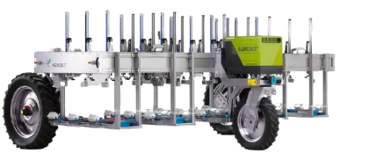
Table of contents
1. Crops 0
1.1 Lettuce 0
1.2 Carrot 0
1.3 Radish 1
1.4 Beetroot 1
2. Specifications work zone 2
2.1 Planter 2
2.2 Harvest bins 3
2.3 Competition field 4
3. Contest guidelines and conditions 5
3.1 General rules 5
3.2 Physical conditions 5
3.3 Contest conditions 6
4. Competition rules and scoring 7
4.1 Crop placement 7
4.2 Harvest box and bin assignment 7
4.3 Scoring criteria 7
4.4 Competition procedure 8
4.5 Tiebreaker 8
4.6 Suspended points 8
4.7 Bonus points 8

1. Crops
In this chapter, the crops that need to be harvested are presented. Furthermore
measurements of these crops are shown.

Lettuce
One of the crops to be harvested is a head of lettuce, as shown in Figure 1.
This head of lettuce will only come above the ground with the top part.
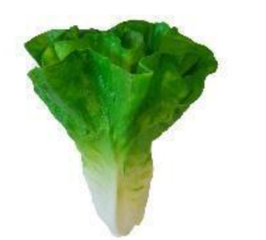
length: 170 mm
Diameter: 160 mm
Link: https://decofoodshop.nl/product/namaak-krop-sla/

Figure 1 Lettuce

Carrot
One of the crops to be harvested is a carrot, as shown in Figure 2. This carrot will only come above the ground with the upper part.

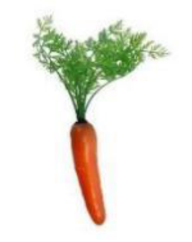
Figure 2 Carrot
length: 300 mm
Diameter: 30 mm
Link: https://decofoodshop.nl/product/namaak-wortel/

Radish
One of the crops to be harvested is a radish, as shown in Figure 3. This radish will only come above the ground with the top part.
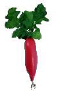
length: 180 mm
Diameter: 30 mm
Link: https://decofoodshop.nl/product/namaak-radijs/

Figure 3 Radish

Beetroot
A beetroot is one of the crops to be harvested, as shown in Figure 4. This beetroot will only come above the ground with the top part.
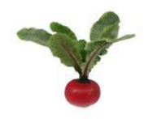
length: 300 mm
Diameter: 90 mm
Link: https://decofoodshop.nl/product/namaak-biet/
Figure 4 Beetroot

Specifications work zone
In this chapter specifications are given on the work zone of the Agrobot gantry challenge. Measurements of the planters are given. Furthermore specifications are given about the harvest bins and the competition field.

Planter
The field will consist of 4 planters per team. The planters measure 1000x1000x200 mm and contain 9 pixels, as shown in Figure 5. The width of the planter corresponds to the working width of the original gantry of previous projects.

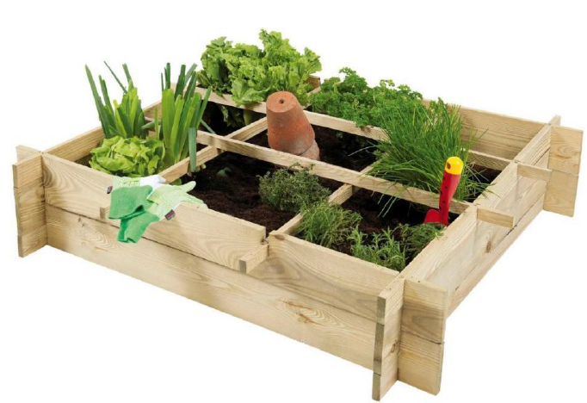
Figure 5 Planter
Each pixel will have a separate crop. The crops will be distributed across the planters in a random pixel pattern. A pixel will be approximately 300x300 mm. Each crop must maintain a minimum distance of 200 mm from each other.
The planter can be found in the next link: https://buitengoed.nl/artikel/21984/woodvision-minigarden-afm-90-x-90-x-20-cm-geimpregneerd-grenen.html

Harvest bins
The intention is that the crops are drawn and placed in different harvesting bins. These harvest bins measure 400x300x170 mm. Because there are four different crops, four different harvest bins are also placed. The colors of the harvest bins are yellow, red, green and blue as shown in Figure 5. The team can decide for themselves where the harvest bins will be placed. The harvest bins have different colors so that they can be distinguished by vision or sensors.

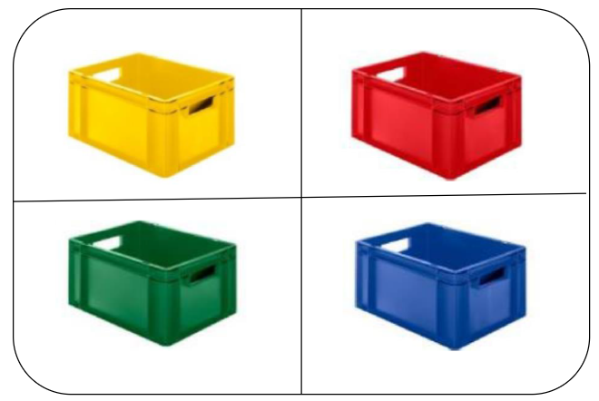
Figure 6 Harvest bins

Link yellow harvest bin:
https://www.norah.nl/plastic-stacking-bin-colour-yellow-closed-with-open-handles-size-40-x-30-x-17-cm.html
Link red harvest bin:
https://www.norah.nl/plastic-stacking-bin-colour-red-closed-with-open-handles-size-40-x-30-x-17-cm.html
Link green harvest bin:
https://www.norah.nl/plastic-stacking-bin-color-green-closed-with-open-handles-size-40-x-30-x-17-cm.html
Link blue harvest bin:
https://www.norah.nl/plastic-stacking-bin-color-blue-closed-with-open-handles-size-40-x-30-x-17-cm.html

Competition field
The competition field will consist of 4 planters per team. The dimensions of the competition field are shown in Figure 7. Each team will bring their own planters to the game. At the beginning or end of the competition field, bins will be placed in which the crops must be put. The competition field will be filled with approximately 50 mm of dirt. The biggest distance in height between driving paths is 100 mm.

Figure 7 Competition field

Contest guidelines and conditions
This chapter is dedicated to the presentation of general guidelines of the competition. Furthermore physical conditions on the Agrobot are shown.

General rules
Each team has to create their own Argobot. They are responsible for designing, creating and transporting their robot to and from the competition. The Robot should abide by the physical and contest rules to be valid to join the competition. Each robot should also have a bill of materials. Every part of the robot should be listed on this bill, including the price and origin.

Physical conditions
These are the conditions of last year:
Maximum dimensions of the Agrobot Gantry have been determined. This has been determined based on the work area of Agrobot Gantry's previous models. As shown in Figure 12, these dimensions match the size of the planters and the field. This must be taken into account in the design and realization. In Table 1, all physical conditions of the Agrobot Gantry can be found.
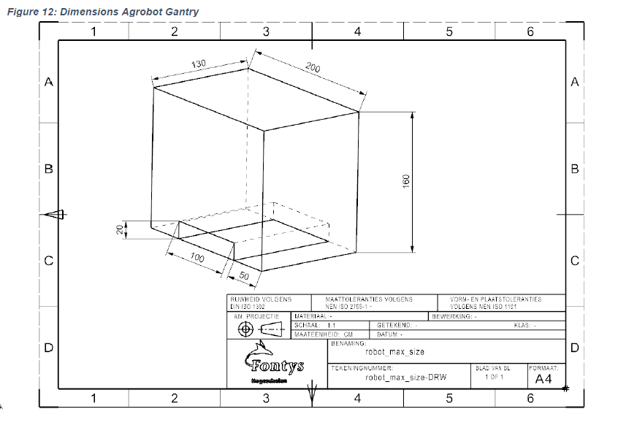
Table 1 physical conditions
Physical conditions | Values
Maximum height | 1.6 m
Maximum depth | 1.3 m
Maximum width | 2.0 m
Maximum ground pressure | 9 N/cm²

Contest conditions
During the competition, there are several conditions that the Agrobot Gantry must meet. These different conditions can be found in Table 2.

Table 2 Contest conditions
Contest conditions | description
Displacement | The Agrobot Gantry must be able to  move at least four planters overall
Positioning | The Agrobot Gantry must be able to determine its position on the field and autonomously drive through the field. There is no fixed path, and each group can decide how the robot can travel.
Harvest | The Agrobot Gantry must be able to pick up individual crops and place them in a harvest bin.
Image recognition | The Agrobot Gantry must move to the correct position of a crop to be harvested using vision software or other sensors.
Battery | The robot must be able to operate for at least 15 minutes (competition duration) without an external power source.

Competition rules and scoring
The competition will take place at Curio Greenhouse in Breda on Thursday, the 23rd of January 2024.

Crop placement
Each team gets to place the crops their selves in the first planter. The crops in the remaining three planters are positioned randomly by the opponents. These crops will be placed 50 mm into the dirt. A total of 36 crops will be placed at random by the other teams.

Harvest box and bin assignment
The teams can decide for their selves in what box they want to place the crops. After this, the crops need to be placed into the harvest bins. Before the race begins, the team must tell in advance which color harvesting bin they will use for which crop.

Scoring criteria
1 point: For every crop they harvest.
2 points: For each crop, they harvest and place in a Harvest Bin.
3 points: For each crop, they harvest and place it in the pre-arranged color harvest bin.
-1 point: Each time the robot touches a planter box, the team loses 1 point.
Jury
Every team will give a 10-minute presentation in front of the jury about the considerations behind the design of their prototype.
Based on these presentations, the jury will give points to three categories:
- money
- innovation
- Future use

That means that a team can get max 15 points from the jury on top of the test score. This way, the test remains the most important part of the total score.
For the category "money", the teams will provide the jury with a bill of materials and the money they spent regarding their prototype.

Competition procedure
Each team gets 15 minutes to harvest as many crops as possible and place them in the harvest bin. At the beginning of the competition every Agrobot will start at a distance of 1000 mm compared to the planter. During the race, the Agrobot may be rested and possibly operated manually to return to the starting point. Damaged crops may not be placed in the ground again and if the robot gets stuck, the robot may possibly be picked up and placed in the starting position. If there is an obstacle, the robot only needs to stop. The Agrobot is required to turn at least once during the competition, otherwise all points will be suspended.

Tiebreaker
The team with the most points within 15 minutes wins. If it appears that there is a tie between 2 teams, the team that reaches the last point the fastest wins.

Suspended points
If the crop gets ran over, scratches, indentations or dropped from a larger distance then 200 mm, the points you could get from that crop are suspended.

Bonus points
There will be given one extra bonus point to:
- The least heavy robot
- The robot with the smallest volume

